YEAR 10 SCIENCE (MODIFIED)
EXAMINATION REVISION - SEMESTER 2 2012

Natural and Processed Materials

1. The periodic table is useful for chemists as it arranges the elements in a particular way.

(a) What is a group?

(b) Why are elements put into a particular group?

(c) What are the group numbers of:

(i) alkali metals?

(ii) inert (noble) gases?

(iii) halogens?

(d) Where do you find the following elements in the table? Indicate them on the periodic table below, either
by labelling or colouring.

(i) transition elements
(ii) metalloids / semi-metals

(e) Where do you find the non-metal elements? Show this on the diagram below.

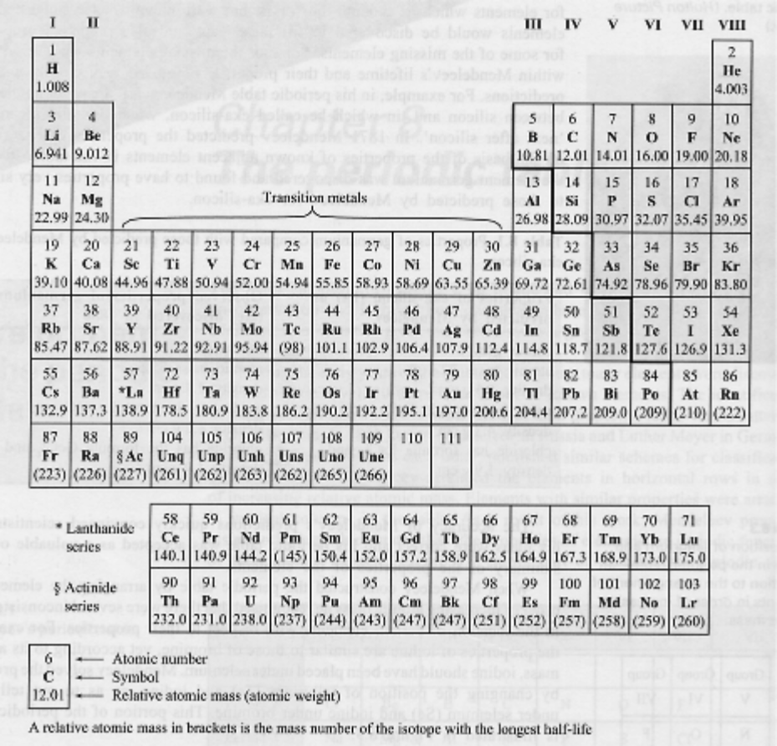

2. Give a definition or description for the following terms.

(a) element

(b) atomic number

(c) atomic mass

(d) valence electron

3. Complete the following table.

ELEMENT | PROTON NUMBER | NEUTRON NUMBER | ELECTRON NUMBER
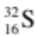
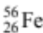
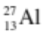

4. Draw clear diagrams to show the electron configurations of the following elements.

(a) 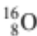 (b) 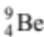

(c) 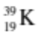 (d) 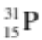

5. can form a 2- ion (O²⁻).

(a) Were electrons gained or lost to form the O²⁻ ion?

(b) How many electrons were gained or lost?

(c) In which group is O?

(d) What valency do all members of this group possess?

6. (a) Use the list of ions to write the names of the following copounds

COMPOUND | FORMULAE
FeCl₃
MgI₂
Fe(NO₃)₃
BaCO₃
(NH₄)₂S
Al(OH)₃
PbSO₄
KCH₃COO
Zn₃(PO₄)₂
CuSO₄

(b) Write the number for the following prefixes.

di- penta- mono- tetra-

(c) Use prefixes to write the name of the following.

SO₃
P₂O₅
SF₆
NO₂

7. Balance the following equations.

(a) MgO_{(s)} + HNO_{3(aq)}  Mg(NO₃)_{2(aq)} + H₂O_{(l)}

(b) Al_{(s)} + Cl_{2(g)}  AlCl_{3(s)}

(c) Ba(NO₃)_{2(aq)} + K₃PO_{4(aq)}  Ba₃(PO₄)_{2(s)} + KNO_{3(aq)}

(d) C₆H₁₂O_{6(s)} + O_{2(g)}  CO_{2(g)} + H₂O_{(g)}

8. Write complete word equations for the following acid reactions.

(a) magnesium + sulphuric acid 

(b) calcium hydrogencarbonate + nitric acid 

(c) zinc hydroxide + hydrochloric acid 

Physical Sciences

1. (a) Define the meaning of the following.

(i) Distance

(ii) Displacement.

(b) A man drives his car 800 m due East and then turns North, driving 300 m before stopping at a petrol
station.

(i) Calculate the distance he has driven.

(ii) Draw a vector diagram to show this movement. Remember to draw arrows and a resultant vector.
(Use the scale 1.0 cm = 200 m.)

(iii) Calculate the displacement made from home to the petrol station using a ruler and protractor.
Show your working clearly.

2. A group of students produced the following ticker tape. One dot is recorded every 0.02 seconds.

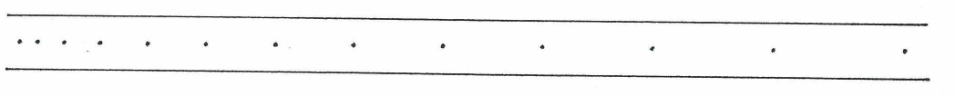

(a) Describe the type of motion shown by the tape.

(b) Choose any 6 dots (5 dot-spacings) and answer the following questions.

(i) How long is the time for 5 dot-spacings?

(ii) Accurately measure the distance for the 5 dot-spacing and record it in centimetres and convert it to
metres.

d = cm = m

(iii) Calculate the speed represented by the dots you have chosen. Show your working.

3. The graph below shows the motion of a car along a straight road.

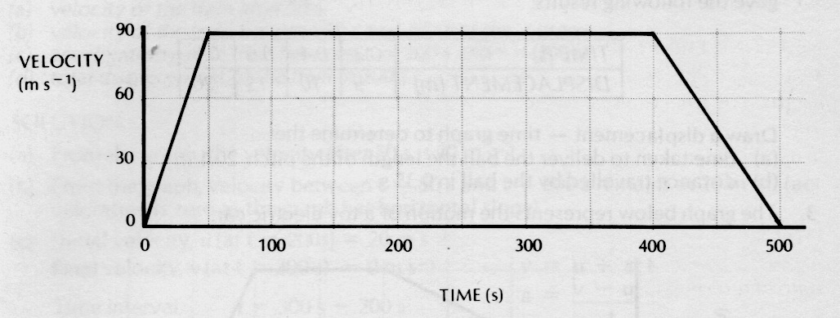

From the area under the graph, determine the displacement of the car over the entire motion.

4. A balloon filled with hydrogen gas has a velocity of 40 ms⁻¹ East. How long will it take to go 450 m ?
(Hint: Use v, s, t.)

5. What is the average speed of a plane if it flies 2700 km in 2.3 hours? Give the answer in kmh⁻¹.
(Hint: Use speed, d, t.)

6. A top sprinter reaches 11.2 ms⁻¹ within 3.15 s of the start of a race. Calculate the average acceleration.
(Hint: Use v, u, a, t.)

7. A car of mass 1530 kg is travelling at 70.0 kmh⁻¹ along Hepburn Avenue when the driver has to brake sharply to
avoid a small child who suddenly appeared on a bike crossing the road.

(a) Convert the velocity of the car to ms⁻¹. (Hint: Check the data sheet for the factor to use.)

(b) If it took 3.5 s to stop the car, calculate the average force exerted by the brakes.
(Hint: Use F, m, a.)

(c) The driver of the car was an engineer and had a hard-hat sitting on the back shelf. Describe what
happened to the hard-hat in this situation and explain why it took place.

8. (a) Explain the difference between mass and weight. Give an example to help your explanation.

(b) The acceleration due to gravity on Jupiter is 22.5 ms⁻². Calculate the weight of a 450 kg object on Jupiter.
(Hint: Use F_{w}, m, g.)

9. A 70.0 kg cyclist is applying a force of 150 N forwards but is working against a wind producing a friction force
of 80 N opposing the movement.

(a) Determine the resultant force for this situation.

(b) Calculate the acceleration of the cyclist. (Hint: Use F, m, a.)

(c) It is possible for the rider to move at constant velocity. In terms of the forces acting, explain how this is
possible.

10. You are seating on a seat at the moment. Explain why you don't fall through the chair and are supported by it.
(Hint: Think of Newton's Third Law.)

